Safety Management Council Minutes – November 18, 2021

Call to Order
The meeting was called to order at 8:01 am by Chairman Norm Patchell. Due to COVID, the meeting was convened via ZOOM. Approximately 18 members were present, attendance was not taken.
PRESENTATIONS:
- Fatigue/Impairment monitoring – Carol Setters, Alert Meter – Predictive Safety SRP, Inc.

- Employees may not be capable of accurately judging their own risks when their alertness is impaired.
  - Night shifts and rotating shifts
  - Stress
  - Drug and alcohol use
- Statistics on poor sleep – costs companies millions of dollars
- Reduction in costs with fatigue management programs
- Fatigue Management Approaches
  - Review particular situations
  - Educate workforce– example: offering water/staying hydrated is huge
  - Simple protocols for supervisory intervention
- Driver technologies for detecting fatigue
  - Vehicle Operation Monitors – changes in steering, acceleration or braking
  - Driver Monitors with in-cab cameras – detection of drowsy driver behavior
  - Actography Wearables – hats that detect nodding off
  - Ocular Detection Glasses – detect change is pupils
  - EEG Detection Hats – detect alertness changes in brain waves
- A Day In The Life
  - AlertMeter visual games on a tablet or phone measuring individual’s alertness
  - Rare circumstances where employee tests outside their normal range
  - Supervisor receives notification text or email
  - Company protocol is followed for safety conversation with employee for next steps
- Known Cognitive Issues – fatigue, illness, emotional distress, heat stress and dehydration, drugs and alcohol, etc.
- Fatigue Management DIY – assess fatigue risk, examine schedules, educate employees, NSC Fatigue Toolkit, etc.
- Scott Clark mentioned that this is about being proactive instead of reactive – educate everyone.
- Tim Doyle asked about retesting during shifts – Carol said that companies decide their protocols on how often they will test during the day. Scott they retest during the day.

- Close calls/near misses – Norm Patchell, Safety Director, HO Bouchard
- HO Bouchard uses KeepTruckin
- Inward and outward facing cameras
- Showed how system works and data that can be reviewed
- Scott Clark, Savage Trucking, shared some examples of their dashcam recordings – they are switching camera systems for better clarity
- Dave Smiley asked about how the specific recording that we watched started – answer: driver initiated for camera system to record so it would be saved
- Norm asked about how recordings are saved – old camera system uses a SD card
- Jessefa Murphy asked about sound with recordings – Scott said different systems have different options
- Videos are saved and many times used for driver education
OLD BUSINESS:
- MMTA/APTA Transportation Safety Conference Wrap-up – Tim Doyle
  - Feedback was it was one of the better conferences even though it was a smaller group
  - Presentations are available for review – https://www.mmta.com/tsc21/
  - Canadian team will let us know where the conference will be next year

- Entry Level Driver Training – Impact on Carriers – Randy DeVault
  - 2/7/2022
  - Those providing their own training, you have to have a curriculum that meets federal standards. The one being recommended is from JJ Keller. See information and link below.
  - As long as driver gets permit before Feb 7th, will be all set.
  - FMCSA ELDT link – https://www.fmcsa.dot.gov/registration/commercial-drivers-license/entry-level-driver-training-eldt
    - Can register now to be approved training FMCSA training facility
  - Randy mentioned that there are also State of Maine standards for being an Instructor that must be met if you receive payment for services as a school (Chapter 9 rules of SOS).
  - Norm asked about a driver who has never had hazmat needing the endorsement – need to go through training – not for renewals, only new

Link to JJ Keller information:

https://www.jjkeller.com/Category/custom-entry-level-driver-training-manuals?krypto=r8Gd2NpzpdBou0b1DJNe1LGQjR8wg7sQED5YhPo9hF9Flg1KetW8Ty97whISLQfGrg9SZCZ7Zg56dnNgiNg6xGT7AbQdmhQVKdnmeqd1o%2FtpSQH%2FBGco1n%2FfBbWyqfEoLBmo%2BL312YmJ0uj%2Fj1AIAWiLTgzmsKpCUQ2SWzOuBkz8wlF5odWJxV%2BGOo18lFlo&#facet:&productBeginIndex:0&facetLimit:&orderBy:&pageView:grid&minPrice:&maxPrice:&pageSize:&

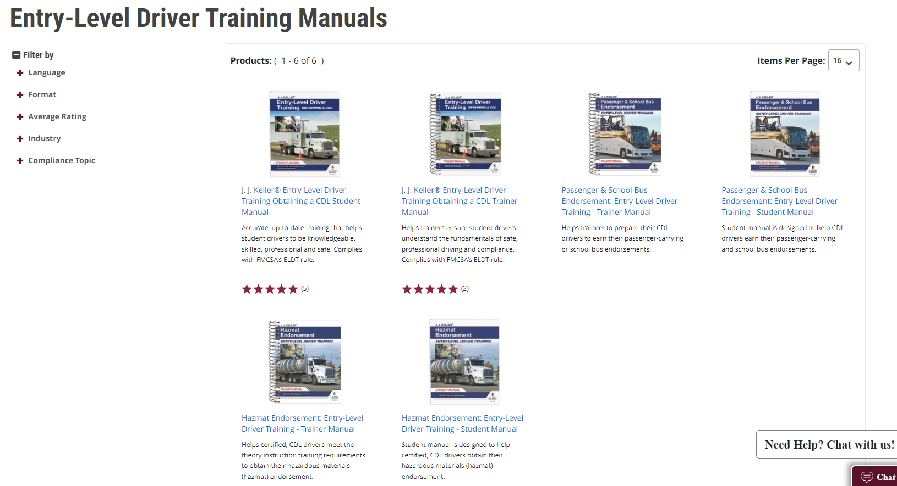

- TDC/PTSC – Randy & Tim
  - Going to have to promote to get back into competition mode
  - Need drivers and technicians, equipment, volunteers
  - May 21, 2022
  - Committee will be meeting soon to begin preparations

- Fleet Safety Awards – Tim
  - Phase 3 of the process is next week
  - Need to encourage others to put in for the Fleet Safety Awards

NEW BUSINESS:
- Annual Banquet – Tim
  - Virtual Annual Banquet for 2022 – Live event January 6th, 3 pm, comedian will be live

- Topics for meetings – May will be with MSP
  - Asked members to suggest topics for future meetings.

The meeting adjourned at approximately 09:20 am.
Respectfully Submitted,
Nycole McGlauflin

