Case Information:

Accident Type: Fatal Date: Click here to enter a date.
Trooper/Inspector: SP Case #:
Town/ City: Route/Street:
Primary Agency/ Troop: Primary Officer:
Reconstructionist: Aspen Report#:
MCRS Accident Report completed by:

Motor Carrier Information:
Carrier Name: | Carrier USDOT #:

Carrier Identified By:
☐ Vehicle Marking ☐ Vehicle Registration ☐ Bill of Lading ☐Lease Agreement ☐ Driver Interview

Driver Information:
Driver Name: | OLN:
DOB: | Phone/Cell Phone:
Sex: Male | License Class:
Endorsements: | Restrictions:
Issue Date: | Expires:
Medical Certificate Exempt: No | Valid Medical: Yes

CMV Passenger Information:

Passenger Name: Passenger DOB:
Passenger Phone Number:

Carrier/ Vehicle/ Driver Documents Checked:
☐ Power Unit Registration ☐ Driver’s License
☐ Trailer Registration ☐Driver’s Medical
☐ Insurance Info. ☐ Lease Agreement between carrier and R/O
☐ Fuel Tax ☐ Daily Vehicle Inspection Reports
☐ UCR ☐ Log Book/ Hours of Service
☐ BOL or shipping papers

Hours of Service:
(Check one)
☐ Interstate Log Book ☐ Intrastate Log Book ☐ Federal 100/150 Air Mile ☐ State 100 Air Mile

☐ Driver interviewed for fatigue.
☐ Driver interviewed for impairment.
☐ Driver interview for possible medical conditions.
☐ Driver interview for last 48 Hrs. of Work/Free Time/ Sleep Cycles
Is vehicle equipped with Electronic Log? ☐ Yes ☐ No
Is vehicle equipped with GPS Tracking? ☐ Yes ☐ No
Is Vehicle equipped with EZ Pass? ☐ Yes ☐ No Transponder #

Drug and Alcohol Testing (applies only to drivers required to have a CDL):

Is the driver enrolled in a random testing program? ☐Yes ☐No ☐Unsure
Were you drug tested when you were hired? ☐Yes ☐No
When was the last time you were tested?

Rolling Radius (center of axle hub to the ground):
Axle 1 | Axle 2 | Axle 3 | Axle 4 | Axle 5 | Axle 6

Wheel End Weights:
1 Right | 2 Right | 3 Right | 4 Right | 5 Right | 6 Right
 |  | Scale Weight | Scale Weight | Scale Weight | Scale Weight
1 Left | 2 Left | 3 Left | 4 Left | 5 Left | 6 Left
 |  | Scale Weight | Scale Weight | Scale Weight | Scale Weight

Slack Adjuster Lengths (Center of cam shaft to center of clevis pin):
1 Right | 2 Right | 3 Right | 4 Right | 5 Right | 6 Right
1 Left | 2 Left | 3 Left | 4 Left | 5 Left | 6 Left

Accident Description/ Possible Causation Factors:

MAINE STATE POLICE
COMMERCIAL VEHICLE
DIMENSION DATA

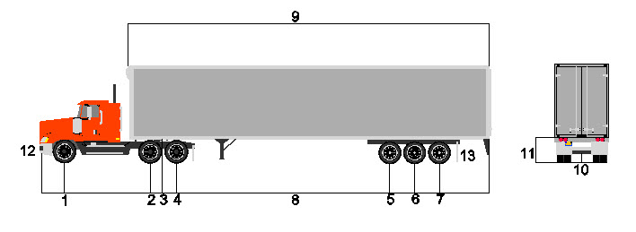
MEASURE FROM FRONT BUMPER TO:

- STEERING AXLE 1 -
- CENTER OF AXLE 2 -
- KING PIN -
- CENTER OF AXLE 3 -
- CENTER OF AXLE 4 -
- CENTER OF AXLE 5 -
- CENTER OF AXLE 6 Enter Distance
- FULL LENGTH OF VEHICLE -
- LENGTH OF TRAILER -
- REAR UNDER RIDE BUMPER TO GROUND -
- DECK HEIGHT OF TRAILER TO GROUND -
- TRACK WIDTH TRACTOR (AXLE 1) -
- TRACK WIDTH TRAILER -

(THIS FORM CAN BE USED TO MEASURE ALL TRUCK CONFIGURATIONS.)

